# Physics 2213A, Modern Physics Prof. Rick Trebino

# Final Exam Spring 2020

# Your Name: __________________________

Please include your name in the file title also.

1. (8 pts) Falsifiability

a) Should a scientific theory be falsifiable or not? Why or why not?

b) Give an example of a theory (in physics or another field) that is not falsifiable.

c) Give an example of a theory in physics that was falsified and what falsified it.

d) Give an example of a theory that has not been falsified and give two examples of observations that failed to falsify it.

2. (8 pts) The Indian Ocean tsunami of 2004 caused significant damage on the *west* coast of Sri Lanka, despite the fact that the earthquake that triggered it occurred almost directly *east* of Sri Lanka, and the tsunami directly struck the east side of Sri Lanka. Provide two physical phenomena that could have played roles in causing this and why.

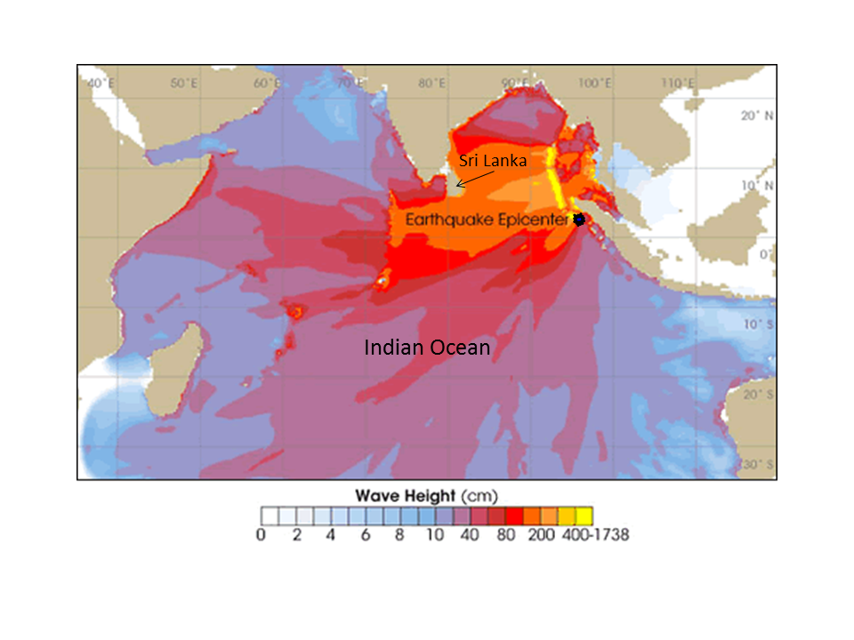

3. (10 pts) Explain Young’s two-slit experiment and its significance for:

a) light in the early 19th century,

b) particles in the mid-20th century,

c) and very weak light beams again in the mid-20th century.

d) What have we learned from these measurements?

4. (8 pts) Atoms

a) How did physicists first determine that the positive charge in an atom is concentrated in a small region in the center?

b) How do we know that a solar-system-like model, in which the electrons orbit the nucleus as planets do around the sun, is wrong?

c) How did Niels Bohr solve this problem?

d) Describe a problem with Bohr’s model of the atom. Briefly (in just two or three sentences), how was this problem eventually solved by later physicists?

5. (8 pts) Why is solving the Schrodinger equation for atoms with more than one electron very difficult? Explain how we approximate the states of such systems. What important principle limits what states an electron can be in, and how does it affect the resulting electron states in an atom?

6. (8 pts) What is the ratio of the minimum uncertainties of the velocities of an electron and a proton confined to the same small region? Define the relevant terms you’ll need to write an expression for this ratio. Before the discovery of the neutron, it was thought that the extra mass of most nuclei was due to extra protons and electrons inside them. Using your result, explain why electrons cannot exist stably within the nucleus (you probably don’t have sufficient numerical data to prove it, but you only need to speculate here).

7. (8 pts) What is blackbody radiation? Give two examples of sources of it. Why is it interesting and important? Why was it a problem for 19th-century physicists? Explain Einstein’s model for it in words. Why is it also important in cosmology?

8. (8 pts) List the absolutely fundamental particles (as we currently understand them) and give a brief description of them. Which are fermions and which are bosons, and what is the defining difference between these two types of particles?

9. (8 pts) A “tachyon” is defined as a particle that travels faster than the speed of light and which still obeys the laws of Special Relativity.

a) If a tachyon has a real value for its total energy, what can we say about its mass?

b) Show that, if it were to slow down (but still travel faster than the speed of light), its energy actually *increases*.

c) Imagine that an observer at rest watches a tachyon speed by at speed v (> *c*). Show that, if the length of the path traveled and the time interval experienced by the tachyon are real as perceived by the observer at rest, then they are both imaginary in the tachyon’s frame and vice versa.

Do you think tachyons are real or imaginary?

10. (10 pts) Imagine that a collision between two distant black holes 100 million lightyears away emits a gravitational wave in all directions that warps space by a peak amplitude of one part in 1012 at a distance of one lightyear away from it.

a) What will its distortion of space be when it arrives at earth (neglecting any expansion of the universe)?

b) If the gravitational wave is incident from a direction perpendicular to the plane of a Michelson-interferometer gravitational-wave detector, each of whose arms is 1km long and involves a laser beam with a wavelength of 1mm, how much will each mirror move, as a result, relative to the interferometer’s beam splitter?

c) Approximately what fraction of a Bohr radius is this?

d) And by what fraction of a fringe would the gravitational wave cause the interferometer output fringe pattern to shift?

11. (8 pts) It’s currently trendy to propose models of our universe that include other universes, as well, and the result is often called the “Multiverse”. One such theory hypothesizes that there are infinitely many “universes”, all packed adjacent to each other in space, some expanding and others contracting. This infinite expanse of “universes” (they’re not really different universes because, if you had enough time and energy, you could travel to them all) is assumed to have existed forever and, although quite variable from place to place (that is, from “universe” to “universe”), has an overall average scale factor, *a*, that’s constant in time. Explain, using a simple 19th-century argument and simple observations that anyone can make, why this cannot be correct.

12. (8 pts) Here’s an interesting parallel-universe scenario that I just made up. Imagine that there is another type of matter that’s exactly analogous to the matter that we’re composed of, but which only interacts with our matter via gravity. It has its own protons, neutrons, electrons, and photons, for example, which have formed stars and planets within our galaxy, but in interstellar space (in between the stars we know) in a manner analogous to our stars and planets. There’s plenty of room in our galaxy for such additional stars and their planetary systems because stars are so far apart. But, because this parallel universe’s matter doesn’t interact with our matter electromagnetically (and its photons can’t be detected), we can’t see it.

a) We actually have a name for this matter already; what is it?

b) How might we detect it?

c) Assume that each parallel universe has a total mass (mass density, actually) approximately equal to ours. Based on measurements already made of our galaxy (and others), how many such universes would there have to be in addition to ours?

d) Describe two observations that imply that this theory is probably wrong (or at least needs to be modified).